|  |  |  |
| --- | --- | --- |
|  | **CAN THO UNIVERSITY SOFTWARE CENTER** |  |
| **MEKONG DELTA - APTECH** |

**Aptech Certified Computer Professional (ACCP)**

**SEMESTER III**

**Institute of Fine Arts**

|  |  |
| --- | --- |
| **Instructor:** | **Class: CP2296F02** |
| Mrs. Ong Thi My Linh | **Team: 4** |
| **Students:**  A19084 - Pham Quoc Anh |

Can Tho, 03/2023

1. **Problem definition of project**
2. **Customer Requirements Specification**
3. **Customer Acceptance Criteria**
4. **Project Plan**
5. **Architecture & GUI Standard of Application**
6. **Interface Design Document**
7. **Table Design Document**
8. **Process Design Document**
9. **Task sheet**
10. **Testing document**
11. **Project Review**
12. **Final Check List**
13. **Installations Guide**

**PROBLEM DEFINITION OF PROJECT**

Our client is an institute by the name “Institute of Fine Arts”, which has been started by the two well-trained professionals who are one of the standard people in the field of animation and fine arts. The procedures that they follow are they first conduct classes on paintings, animation, etc.

During the course schedules, they conduct competitions among the students, for which all the students must participate in these competitions and have to submit their paintings with in the stipulated time. They ask the students to come up with some paintings, which they need to create with their own creativity along with some sentences like poems, quotations, stories, etc. that are to be described along with their paintings. The students based on their creativity, design on their respective computers and then submit their designs (paintings) in the form of a jpeg file, with in the stipulated time to the college.

Once the due date is crossed, the submissions of the designs as created by the students will not be accepted. These students will be disqualified in the competitions. And after the due date the college will not evaluate the designs received from the students based on the creativity and the quotations or poems, and then they will select the best designs and distribute the awards to the students with the best designs.

They at times in order to boost up the competitive spirit in the students, they will display the best paintings done by the students in the exhibitions, at which the paintings will be sold at the price decided by the painter (Student). The money received for the painting which is sold out in the exhibition is handed over to the student itself.

***Existing Scenario:*** *–*

They usually maintain the competition details through pen and paper. Because of which they are facing the problems in retrieving and fetching the records, for which it consumes too much of time, as when a student wants to change the painting submitted, etc. the staff should first search the records and then update the details accordingly.

***Proposed Solution:*** –

Now, the management had come up with a new idea where in they can have a website of their own. In this website they want to implement these competitions, where in they can announce the competitions, provide a facility for the students to upload and download the image files. Also the student can update or remove the pictures of the same. Thus through this website they can automate the process, and as well reduce the time consumption in evaluating and fetching the records of the students, designs, etc. So they had approached you to help them by building a website by building the following functionalities, in it.

**CUSTOMER REQUIREMENTS SPECIFICATION (CRS)**

**Name of Project: Institute of Fine Arts**

1. **Modeling requirements of customer (Use case Diagram)**

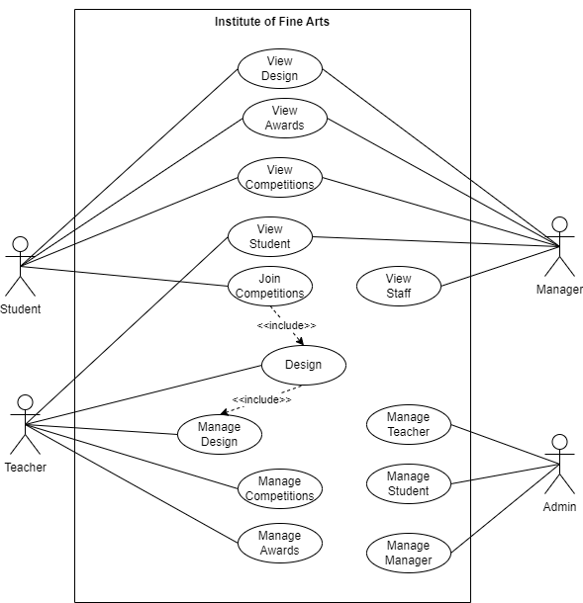

1. **Actor Description**

|  |  |  |  |
| --- | --- | --- | --- |
| **No.** | **Actor** | **Use Case** | **Description** |
|  | Admin | Manage Teacher | This module allows the admin to manage Teacher information consisting of add, update , delete. |
| Manage Student | This module allows the admin to manage Student information consisting of add, update , delete. |
|  |  | Manage Manager | This module allows the admin to manage Manager information consisting of add, update , delete. |
|  | Teacher | Manage Design | This module allows the Teacher to manage design information consisting of update design of the list of the designs that are sent to theCompetitions, along with the price, status,mark,remark,exhibition |
| Manage Competitions | This module allows the Teacher to manage Competitions information consisting of add, update , delete of : the details of the competitions , student’s academic records and upcoming Competitions. |
| Manage Awards | This module allows the Teacher to manage awards information the details of the awards issued |
|  | Manager | View Student | This module allows Manager to view the details of the students |
| View Competitions | This module allows the Manager to view the competition details |
| View Awards | This module allows the Manager to view the details of the awards issued |
| View Design | This module allows the Manager to view product by all the students |
|  |  | View Teacher | This module allows Manager to view the details of the Staff |
|  | Student | Join Competitions | This module allows Student to manage project information consisting of add, update, delete |
| View Competitions | This module allows the Student to view the competition details |
| View Awards | This module allows the Student to view the details of the awards issued |
| View Design | This module allows the Student to view product by all the students |

1. **Use case Description**
   1. **Manage Design:**

* This module allows Student to join the copetition by create new design and manage dseign of themseft by view all design of this student.
* This module allows Teacher to manage information of design consisting of **updating information of design** taken from design of Students participate in the competition.

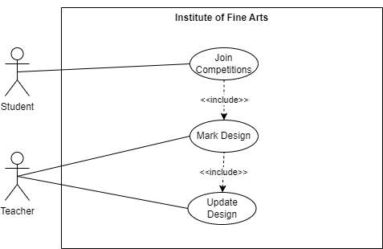

* + 1. **Add New Design**
* Purpose: this function allows Student to add new design.
* Inputs:
  + Name of design
  + Topic of design
  + Description of design
  + Image of design
* Outputs: New design is added to table of database.
  + 1. **Update Design**
* Purpose: this function allows Teacher to update information of product.
* Inputs:
  + Mark of design
  + Remark of design
  + Exhibition of design
  + Status of design
  + Price of design
* Outputs: New information of design is updated to table of database.
  + 1. **Delete Product**
* Purpose: this function allows Student to delete design
* Inputs:
  + ID of design
* Outputs: design is delete to table of database .
  1. **Login**
* Purpose: this function allows User to login into the system
* Inputs:
  + Username of User
  + Password of User
* Outputs: Redirect to the page based on user type
  + If user type is admin then redirect to admin page
  + If user type is manager then redirect to manage page
  + If user type is teacher then redirect to teacher page
  + If user type is student then redirect to student page
  1. **View Student:** This module allows Manager, Admin to manage information of student consist of **view information of** student**.**

**3.4 Manage Competition:** This module allows Teacher to manage information of competition consisting of **adding new competition**, **updating information of competition** and **delete competition.**

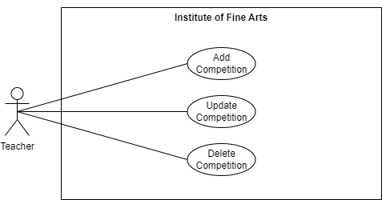

**3.4.1 Add Competition**

* Purpose: this function allows Teacher to add new information of competition.
* Input:
* Competition Name
* Competition Detail
* Competition Start Day
* Competition End Day
* Competition Status
* Competition Reward
* Outputs: New information of competition is added to table of database.

**3.4.2 Update Competition**

* Purpose: this function enables the Teacher to update competition details.
* Input:
* Competition Name
* Competition Detail
* Competition Start Day
* Competition End Day
* Competition Status
* Competition Reward
* Outputs: New information of competition is updated to table of database.

**3.4.3 Delete Competition**

* Purpose: this function allows Teacher to delete of competition.
* Inputs:
* ID of competition
* Outputs: Competition is delete to table of database .

1. **Hardware and Software required for implementing the project**

|  |  |  |
| --- | --- | --- |
|  | **Server** | **Client** |
| **Hardware** | CPU: 2 x 1,6 GHz minimal or 4 x 1,6 GHz recommended. Ram: 4 GB of RAM. 8 GB of RAM recommended. o Hard disk space: Minimum of 800MB up to 256 GB or more of availablespace depending on increasing database o Hard disk speed: To improve performance, install Operating System andproject run on SSD drive. | CPU: 1.8 GHz or faster processor. Ram: 2 GB of RAM. 4 GB of RAM recommended. o Hard disk space: Minimum of 500MB up to 128 GB or more of availablespace depending on increasing database o Hard disk speed: To improve performance, install Operating System andproject run on SSD drive. |
| **Software** | .net framework 4.0 or higher  IIS Server 10 or higher  Sql Server 2019 or higher | Chrome 4.0 or higher  Firefox 3.5 or higher  Safari 4.0 or higher  Internet Explorer/Edge 9.0 higher Opera 10.5 or higher |
| **Additional**  **Technology** |  | |

**CUSTOMER ACCEPTANCE CRITERIA**

|  |  |
| --- | --- |
| **No.** | **Customer’s Acceptance Criteria** |
| 1. | Website graphics |
| 2. | Easy-to-use |
| 3. | Manager Management:   * + Should be able to view the details of the students and staff details   + Should be able to view the competition details that are held till now.   + Should be able to view the details of the awards issued.   + Should be able to view all the postings done by all the students till now based on the competitions that are conducted till now.   + Should be able to view the marks or remarks as provided by the staff for a particular painting.   + Should be able to view the list of the paintings that are exhibited by the staff, along with the details.   + Should be able to maintain the details of the upcoming exhibitions in the country |
| 4. | Admin Management:   * + Maintain (insert, update, delete and search and retrieve) the details of the staff along with the login details, personal details, work details (like when joined this institution, handles which class, handles which subject, etc.), remarks.   + Maintain (insert, update, delete and search and retrieve) the details of the students along with the login details, personal, admission details. |
| 5. | Student Management:   * + The student should be able to view the upcoming competition details along with the awards, details, conditions, etc.   + The student must be able to upload the or the paintings created along with the quotations, stories, etc.   + The student must be able to change the design or the painting, or the quotations or the story or the description for the painting (why did the student created or designed this painting, why should this painting be the best, etc.) or the poem, etc. once is it is uploaded on the site, provided the end date for the competition in which he/she has submitted this design is not exceeded.   + Should be able to view the awards given based on the on the competition conducted.   + Should be able to view all the postings that are marked as best, along with the comments from the staff (areas of improvement, etc.)   + Should be able to view all the postings that are sent for the exhibitions along with the status (like price of the painting, whether the painting is sold or not, whether the student is paid or not, how much is paid by the customer for that painting sold, etc.)   + Should be able to view the marks (best, better, etc.) and remarks (like areas of improvement, positive points, etc.) as posted or provided by the staff, for all the paintings that are posted along with the poems, quotations, etc. based on the competitions conducted and he/she had participated till now. |
| 6. | Teacher Management:   * + View the details of the students (personal, and admission details)   + Maintain (insert, update, delete and search and retrieve) the details of the competitions along with the start date, end date, conditions, award details (like what are the awards that are to be issued for that competition), etc.   + Maintain (insert, update, delete and search and retrieve) the details of the student’s academic records like they can view the postings done (like the designs as posted by the students, details of the quotations, stories, poems, etc. submitted along with the designs, the date on which it is posted, for which competition is posted), and then they can mark it as either best, or better, or good, or moderate, or normal (based on the creativity and the quotations or poems submitted), or as disqualified (if the date submitted is beyond the end date for the competition) and describe the remarks, like the positive points about the design, negative points about the design, and that of the areas of improvement.   + Maintain (insert, update, delete and search and retrieve) the details of the awards issued, like which student is awarded and for which competition did the student is awarded, remarks of the competition.   + Maintain (insert, update, delete and search and retrieve) the details of the upcoming exhibitions that are to be conducted with in the country, so that the students can view the details of the upcoming exhibitions and forward their (students) paintings to the exhibition.   + Maintain (search and retrieve) the details of the students designs submitted based on the mark assigned (like best, better, good, moderate, normal and disqualified), so that they (staff) can forward the best paintings to the exhibitions for the price that the student has quoted.   + Maintain (insert, update, delete and search and retrieve) the list of the designs that are sent to the exhibition, along with the price, and the status (like whether the painting is sold out or not, if sold out, what is the price at which it is sold out, whether the money paid for the painting at the time of sale is returned or paid to the student or not), the details of the customer who purchased the painting if the painting is sold, etc. |

**PROJECT PLAN**

**I. Project Details**

1. Name of the Client: Institute of Fine Arts
2. Date of the Project Plan: 21/2/2023 - 21/3/2023
3. Project Vision/Objectives: (Define the project vision/objectives as stated by the client)

* System can be web-based so that everyone can easily interact with system.
* System can provide optimize functionality.
* System can be customizable so that one can update it.
* System can be flexible enough so that it can incorporate different changes time to time.
* All the information related with Institute of Fine Arts can be documented.
* The most important thing is security. All the data should remain consistent and secure.

1. Scope: (Mention the scope of the project giving the location that will be covered, processed, range of services, and so on)

* Provide detailed information with visual product images
* Filter search function
* Cart feature
* Support many forms of online payment
* Online support/ Online chat
* Product and inventory management
* Function to store buyer information (data)
* Function to report revenue, number of buyers, best-selling products to evaluate business performance
* Order Management

5. Our understanding of the client organization: (Give the range of services, functions, overview of processes, and so on)

* Admin can manage staff, student.
* Staff can manage products, student, competition, mark,remark project of student.
* Student can join competition, create,update,delete project, view reward
* Manager have all information of everything.

6. Project Organization with Responsibilities and Authorities: (Give the name of Project team members their roles and responsibilities)

|  |  |  |
| --- | --- | --- |
| **Member** | **Role** | **Responsibilities** |
| Pham Quoc Anh | Leader | Analysis, Design, Coding,Testing |

**II. Project Initiation/Requirement Documents**

(Information required from the client as inputs regarding his/her system; could be the information about the services, processes, and so on)

* Documents sent by the Indian side
* Source code
* Document user manual

**III. Deliverables**

(The documents to be handed over to the client - such as CRS, Design Document, Installation Manual, User Manual, Maintenance Manual, and Code of documents)

* Design Document
* Source Code
* User Manual

**IV. Project Dependencies**

(Any event or task outside the scope of the project which will affect the success of the project)

* Time
* No experience

**V. Major Project Milestones**

(Generating CRS, Building a Prototype, Gartt - describe the main milestones of the project)

1. Start date: 21/02/2023
2. Requirements analysis: 22/02/2023
3. Functional analysis: 30/02/2023
4. Database and Diagram Design:1/03/2023-10/03/2023
5. Coding: 5/03/2023-20/03/2023
6. Testing: 10/03/2023-20/03/2023
7. End date: 21/03/2023

**VI. Quality Plan**

1. Review Activities (Review meeting participants, frequency, and so on)

* The group works together about 3 times a week and is full of members

1. Testing Activities (Final Test)

* Unit testing
* Integration testing

1. Backup and Recovery Strategies (In case of disk crash, network failures, and so on)

* Google Drive
* Trello
* Github

**ARCHITECTURE & GUI STANDARD OF APPLICATION**

1. **Architecture of Application**

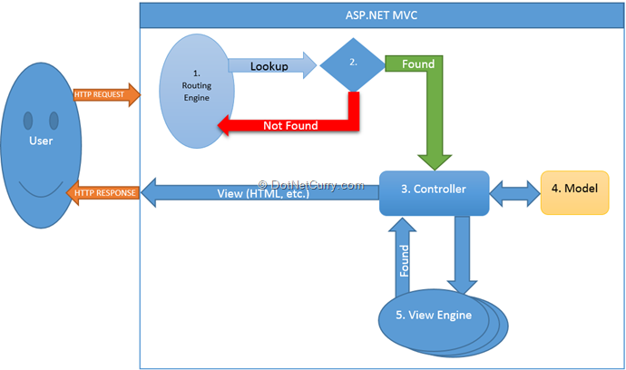

1. **GUI Standard Application**

|  |  |
| --- | --- |
| **Property** | **Value** |
| Document Theme and Color Scheme | Slide – Basic (Elegant) |
| Form - Background Color | White |
| Title - Font Size | 30px |
| Title - Font Color | Black |
| Title - Font Style | Font Awesome |
| Title - Alignment | Center |
| Background color of Controls on the form | White |
| Foreground color of Controls on the form | White |
| Control Caption - Font Size | 16px |
| Control Caption - Font Color | White |
| Control Caption - Font Style | 16px |
| Control caption and controls - Alignment | Center |
| Command button - Alienment | Center |

**INTERFACE DESIGN DOCUMENT**

**1. Home Page**

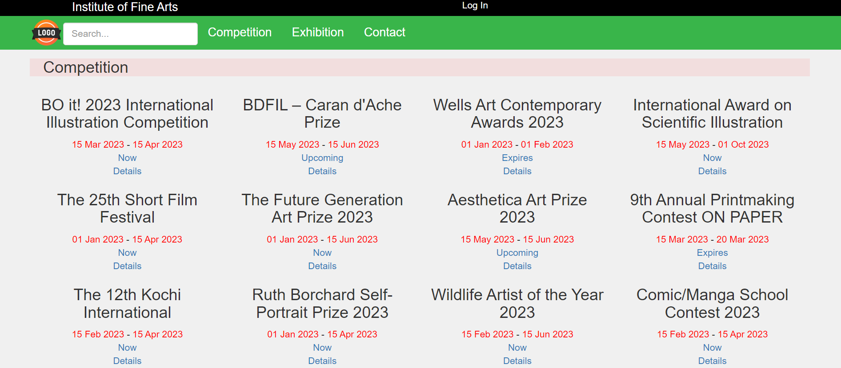

|  |  |
| --- | --- |
| **Controls on the Document** | **Description** |
| Log in link | To login into the system |
| Details button | go to competition detail page |
| Exhibition button | go to choosen design page |

**2.Login**

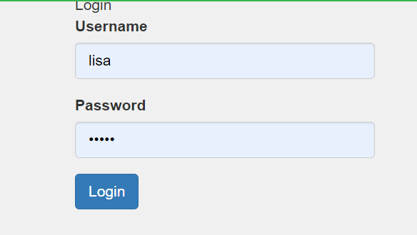

|  |  |
| --- | --- |
| **Controls on the Document** | **Description** |
| Username field | Enter username |
| Password field | Enter password |
| Login button | Login into the system and it have 4 type of user :  1.Login to admin account will redirect to admin page  2. Login to manager account will redirect to manager page  3. Login to teacher account will redirect to teacher page  4. Login to student account will redirect to student page |

**3. Exhibition page**

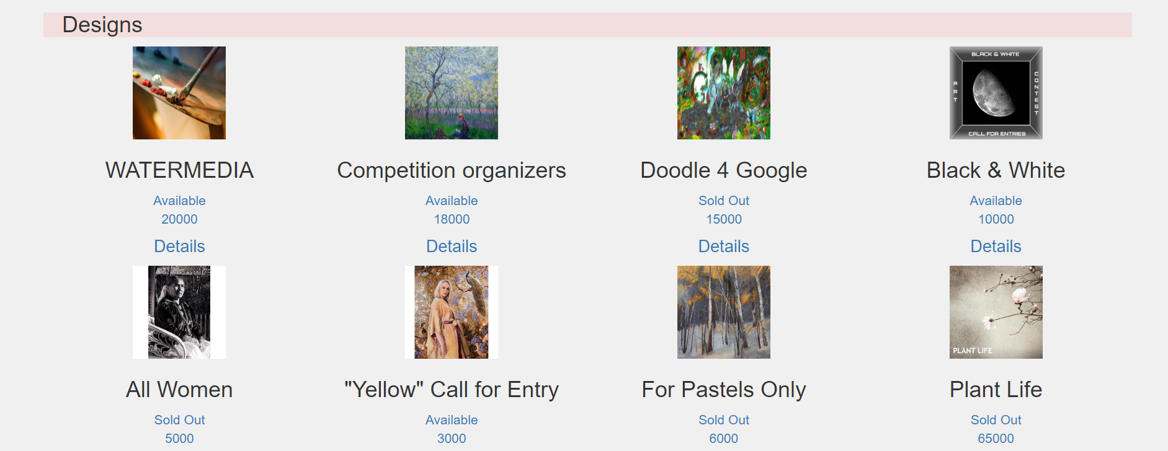

|  |  |
| --- | --- |
| **Controls on the Document** | **Description** |
| Image frame | Display image of design |
| Details button | go to design detail page |
| design status | Display status of design is Available or Sold Out |
| design price text | Display price of design |

**4.Design detail page**

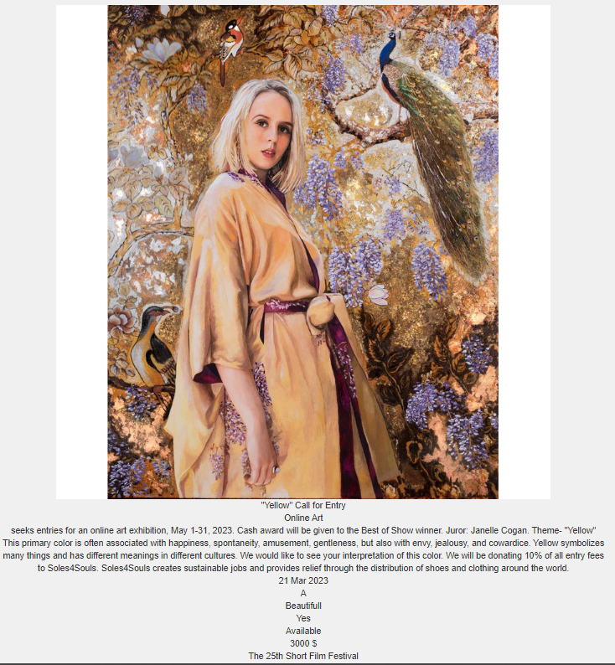

|  |  |
| --- | --- |
| **Controls on the Document** | **Description** |
| Image frame | Display image of product |
| Back to list button | To go back exhibition page |

**5. Contact us page**



**6. Home page for admin**

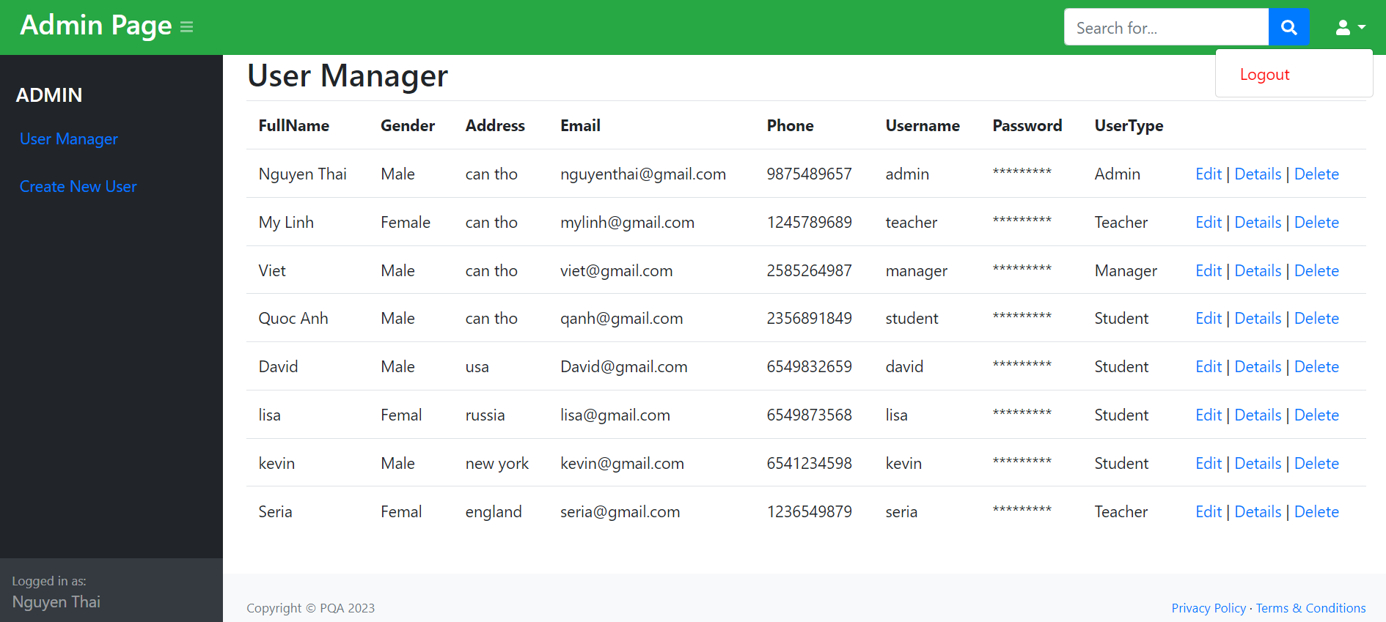

|  |  |
| --- | --- |
| **Controls on the Document** | **Description** |
| Edit link | Display edit user page |
| Delete link | Display delete user page |
| Detail icon | Display detail user page |

**7. Edit User page**

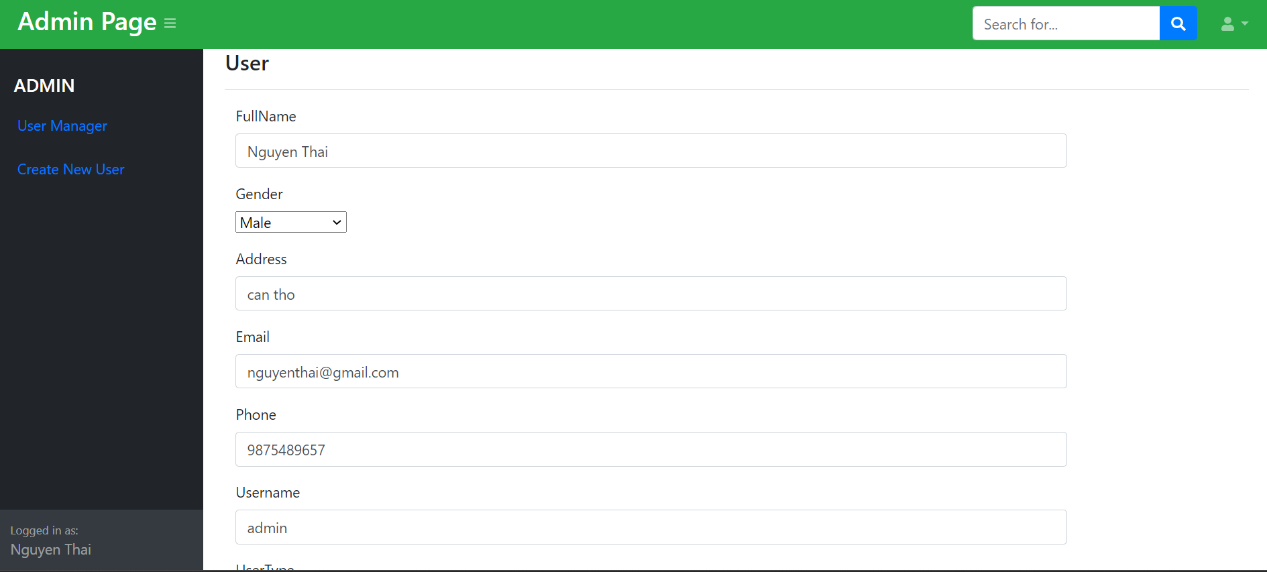

|  |  |
| --- | --- |
| **Controls on the Document** | **Description** |
| Save button | Update user to user table |

**8. Delete User**

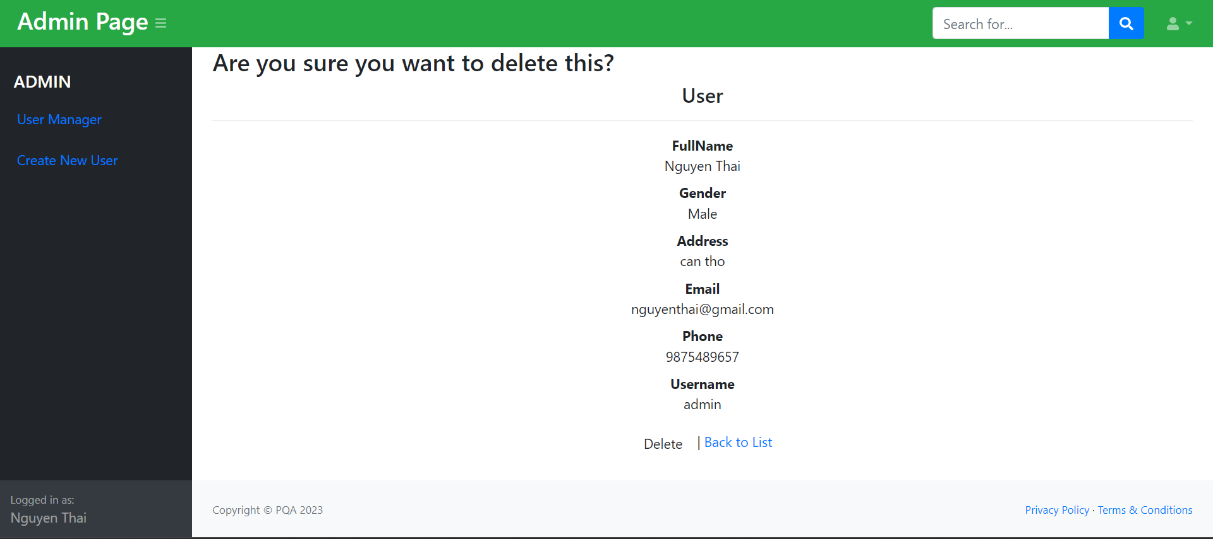

|  |  |
| --- | --- |
| **Controls on the Document** | **Description** |
| Back to list button | Go back user manager page |
| Delete button | Delete user |

**9. Detail user page**

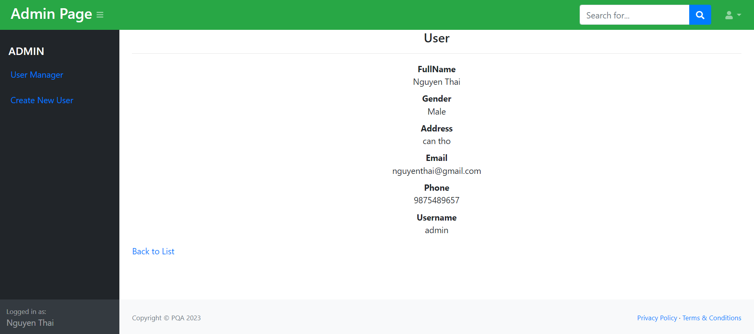

|  |  |
| --- | --- |
| **Controls on the Document** | **Description** |
| Back to list button | Go back user manager page |

**10. Add new user page**

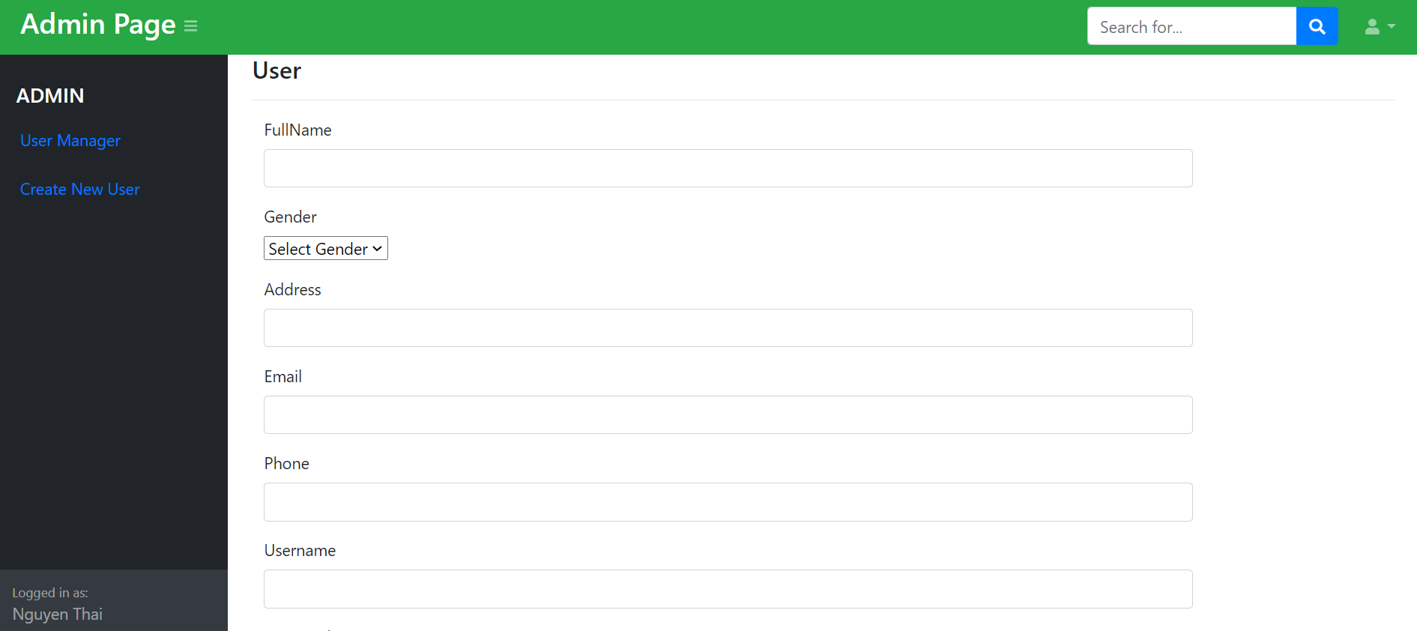

|  |  |
| --- | --- |
| **Controls on the Document** | **Description** |
| Add button | Add new user to user table |

**11. Manager page**

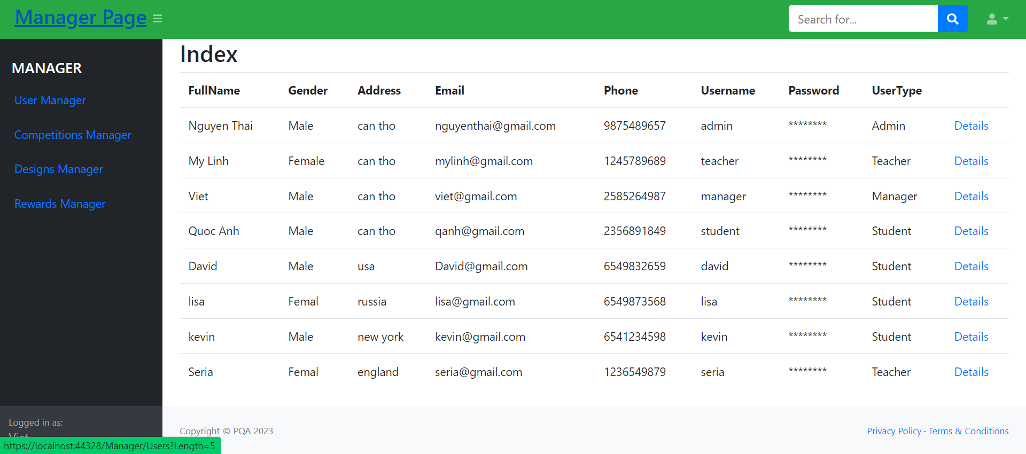

|  |  |
| --- | --- |
| **Controls on the Document** | **Description** |
| Detail button | Go to detail user page |

**12. Manager Competition Page**

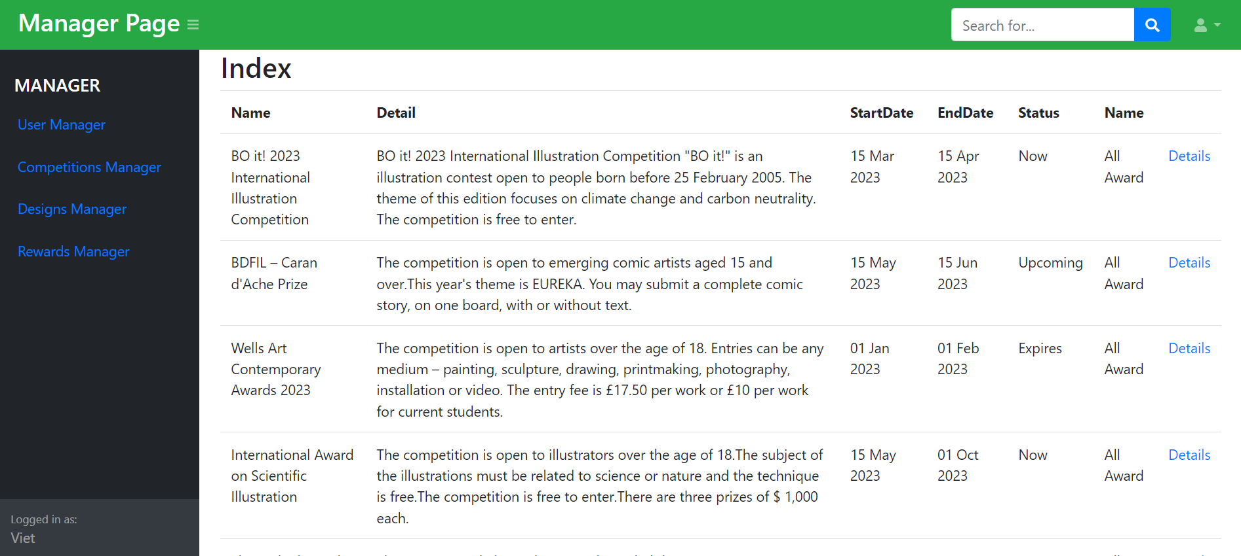

|  |  |
| --- | --- |
| **Controls on the Document** | **Description** |
| Detail button | Go to detail competition page |

**13. Manage Design page**

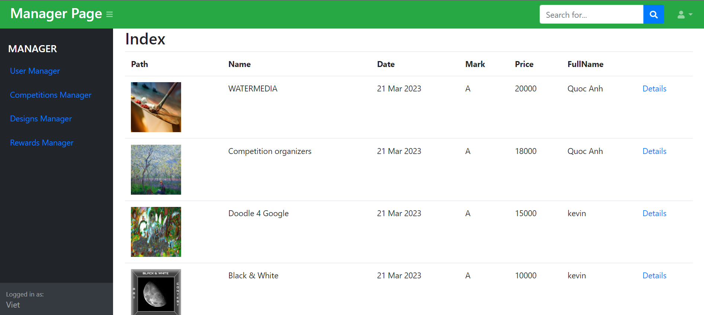

|  |  |
| --- | --- |
| **Controls on the Document** | **Description** |
| Detail button | Go to detail user page |

**14. Manager Reward page**

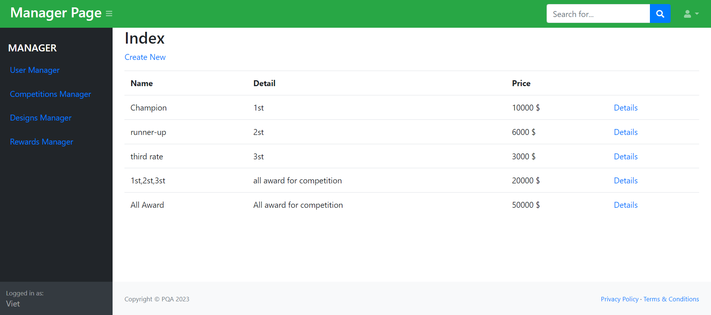

|  |  |
| --- | --- |
| **Controls on the Document** | **Description** |
| Detail button | Go to detail user page |

**15. Student page**

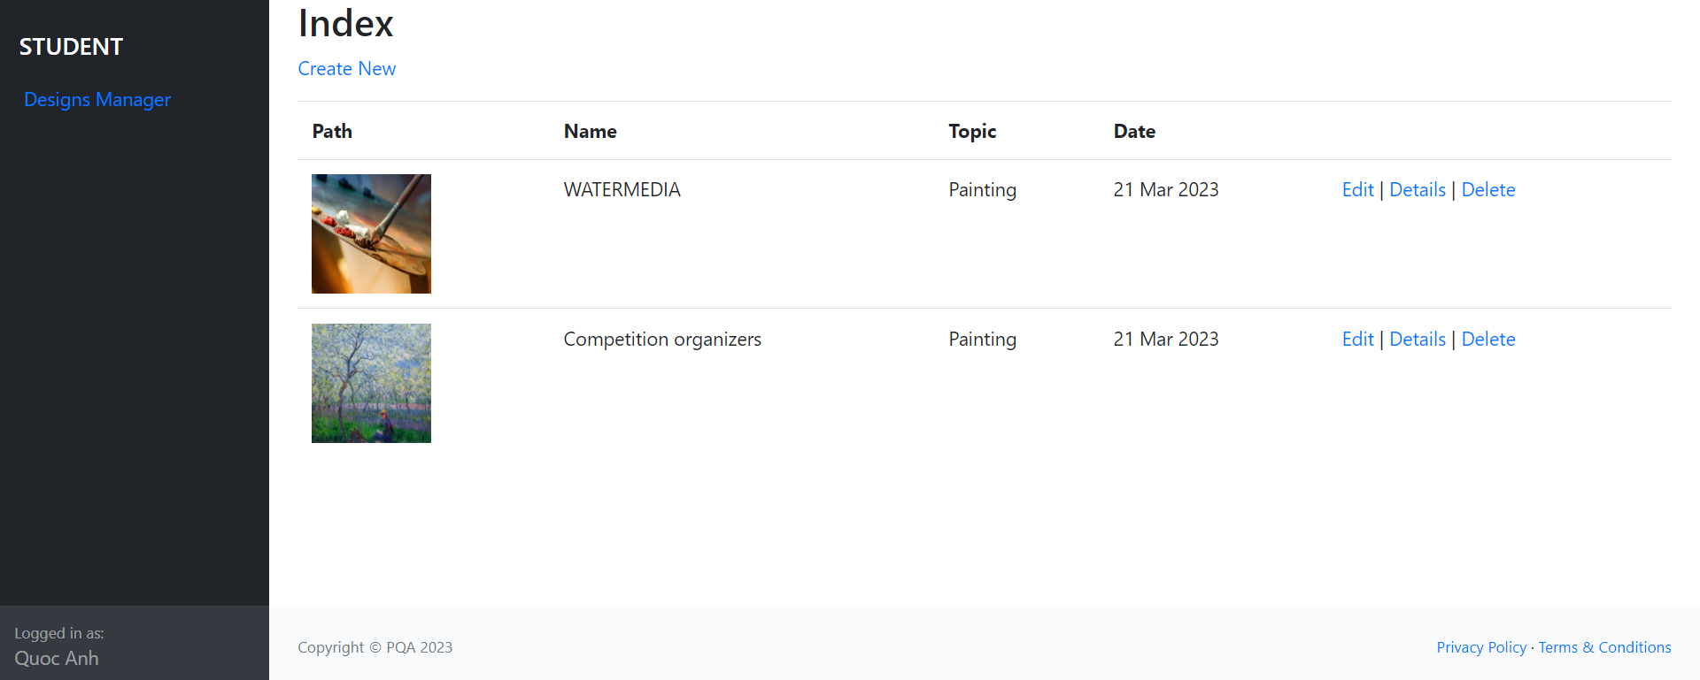

|  |  |
| --- | --- |
| **Controls on the Document** | **Description** |
| Edit link | Display edit design page |
| Delete link | Display delete design page |
| Detail link | Display detail design page |
| Create link | Display Add design page |

**16.Edit Design page**

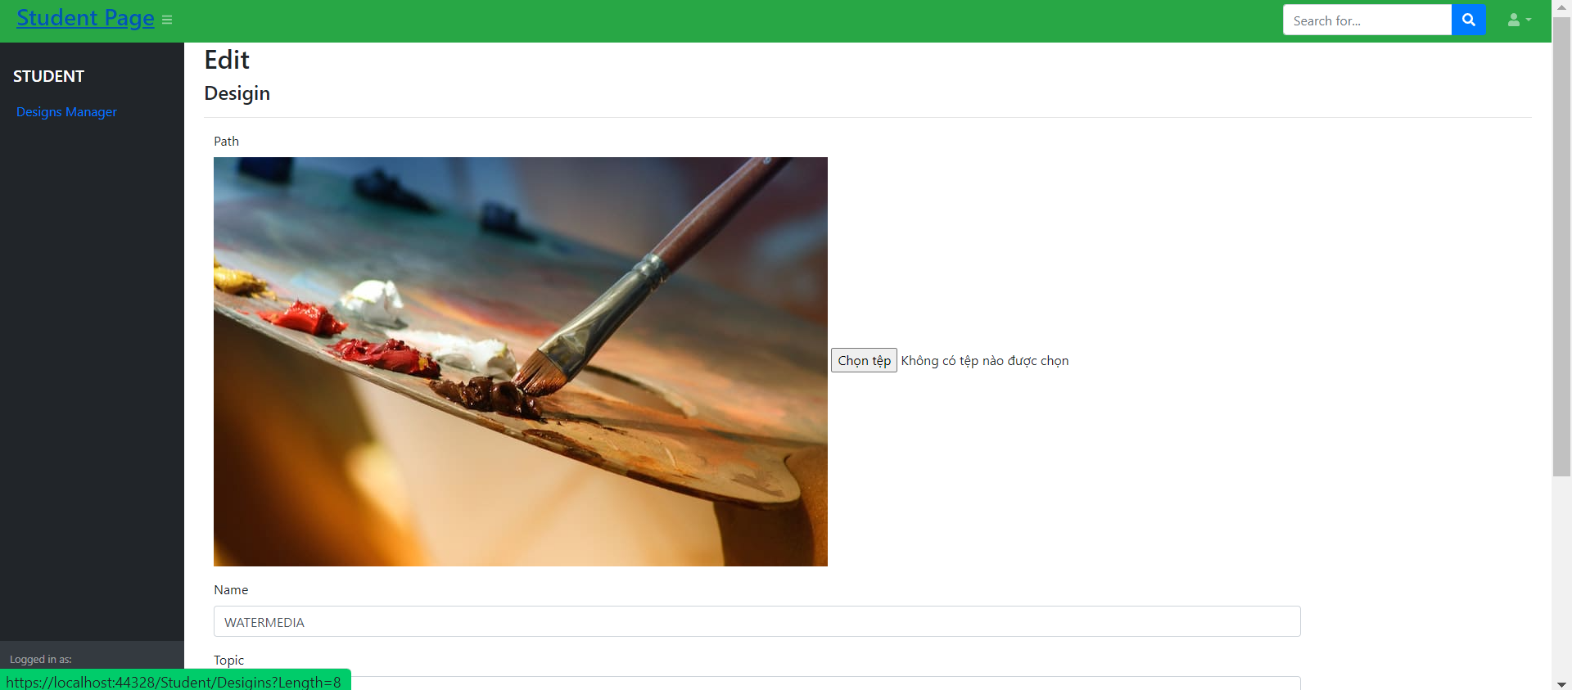

|  |  |
| --- | --- |
| **Controls on the Document** | **Description** |
| Save button | Update design to design table |

**17. Delete Design**

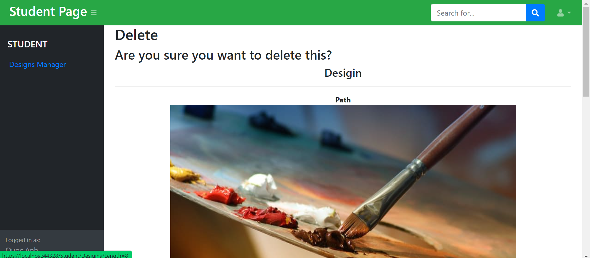

|  |  |
| --- | --- |
| **Controls on the Document** | **Description** |
| Back to list button | Go back user design page |
| Delete button | Delete design |

**18. Detail design page**

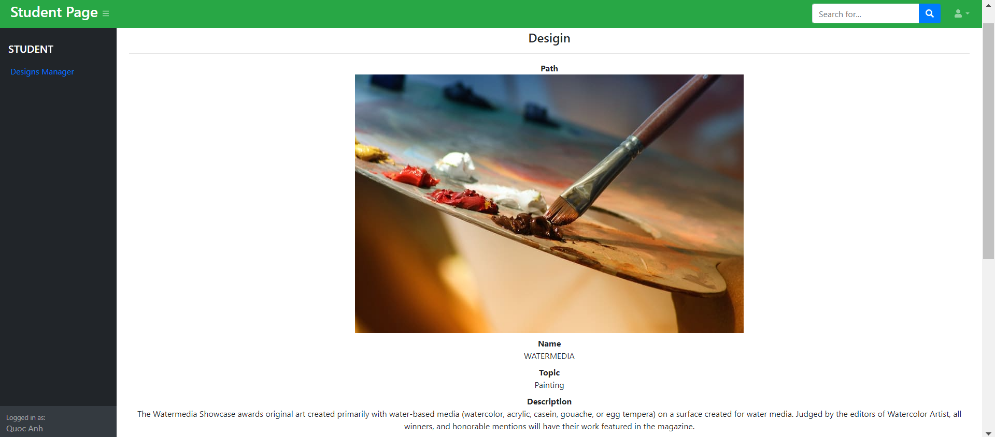

|  |  |
| --- | --- |
| **Controls on the Document** | **Description** |
| Back to list button | Go back user design page |

**19. Add new design page**

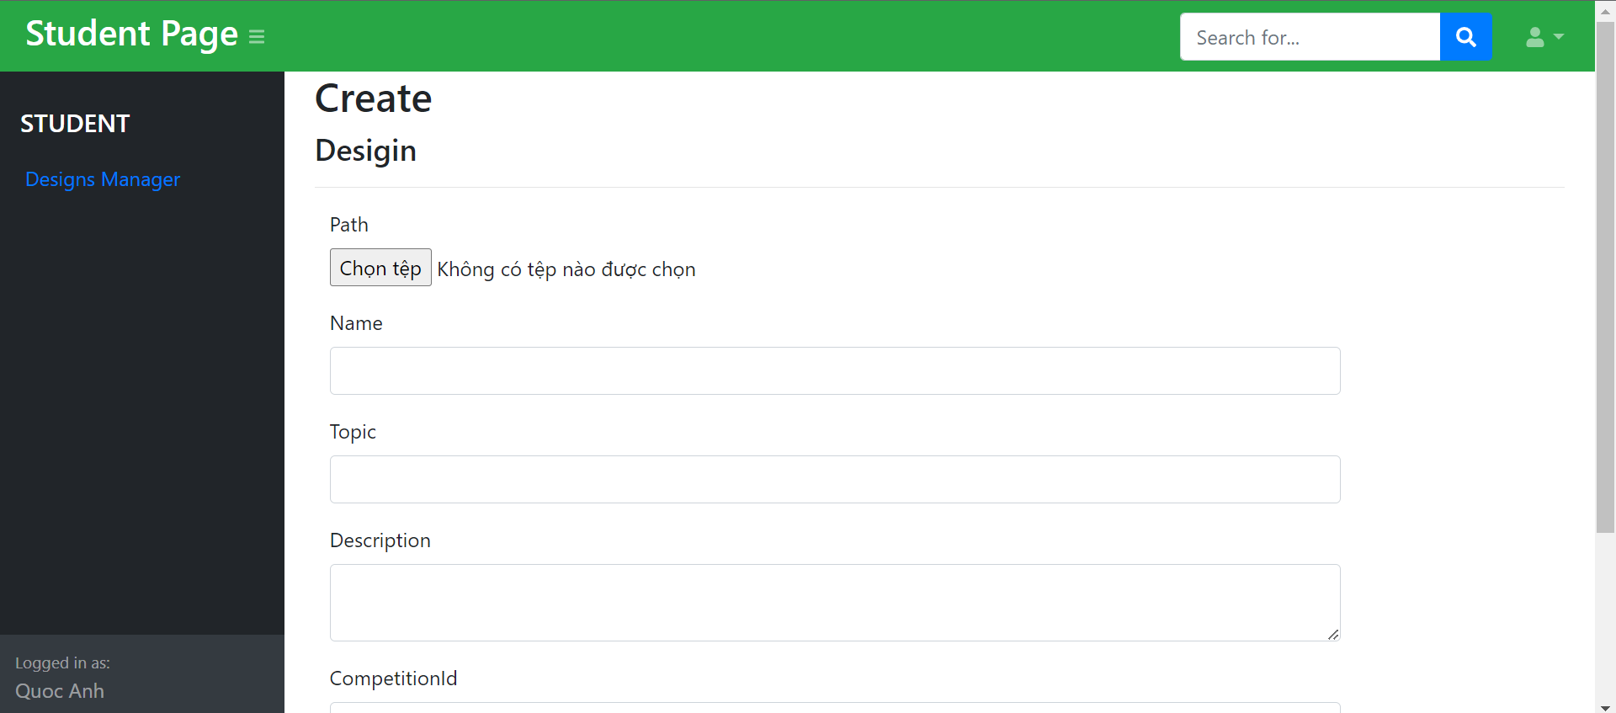

|  |  |
| --- | --- |
| **Controls on the Document** | **Description** |
| Add button | Add new design to design table |

**20. Teacher page**

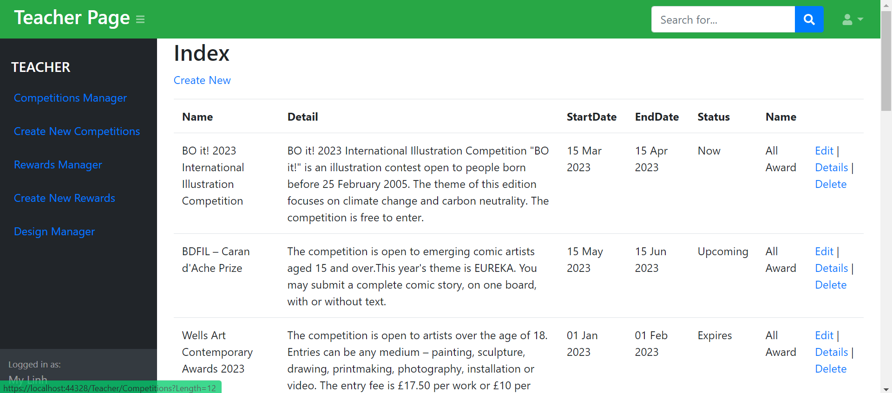

|  |  |
| --- | --- |
| **Controls on the Document** | **Description** |
| Edit link | Display edit design page |
| Delete link | Display delete design page |
| Detail link | Display detail design page |
| Create link | Display Add design page |

**21. Teacher Manager Design page**

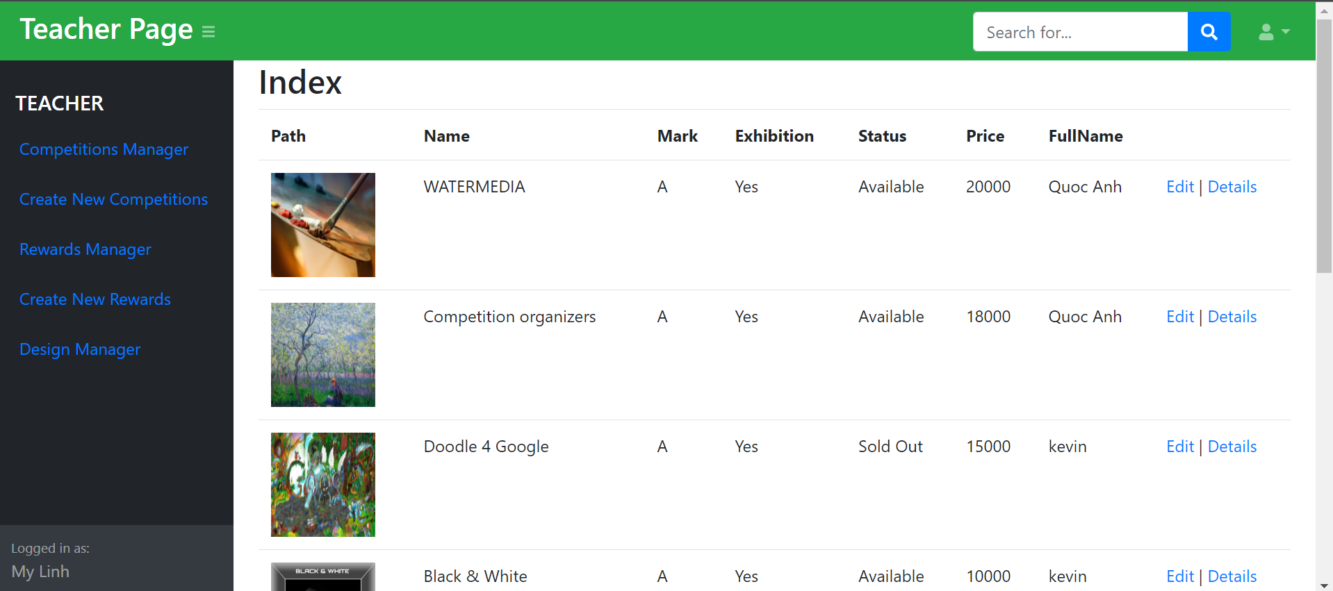

|  |  |
| --- | --- |
| **Controls on the Document** | **Description** |
| Edit link | Display edit design page |
| Detail link | Display detail design page |

**22. Teacher Edit Design Page**

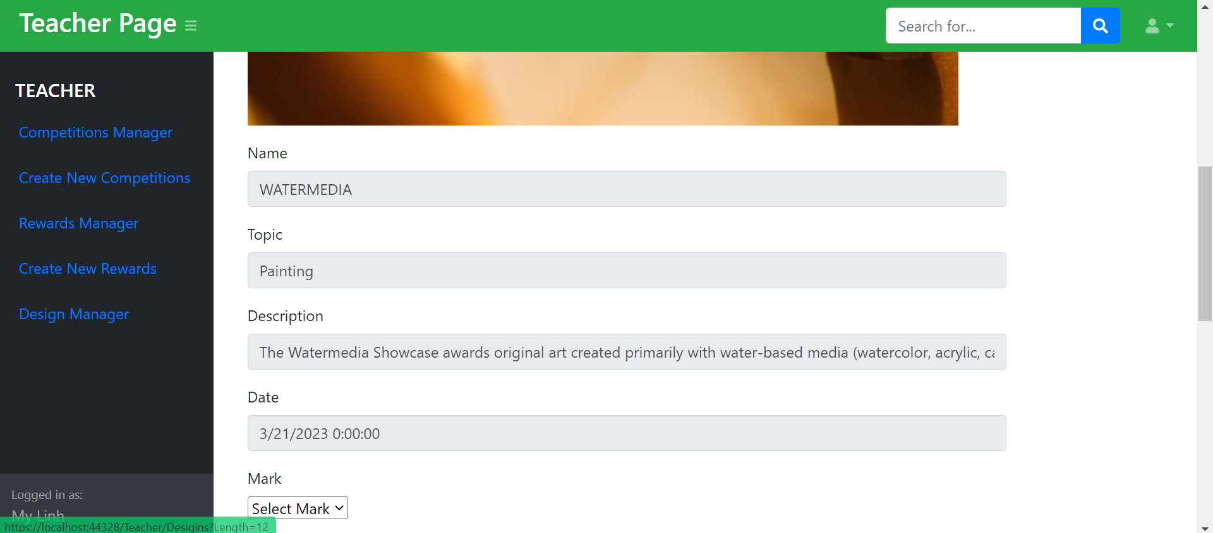

|  |  |
| --- | --- |
| **Controls on the Document** | **Description** |
| Save button | Update design to design table |

**23. Detail design page**

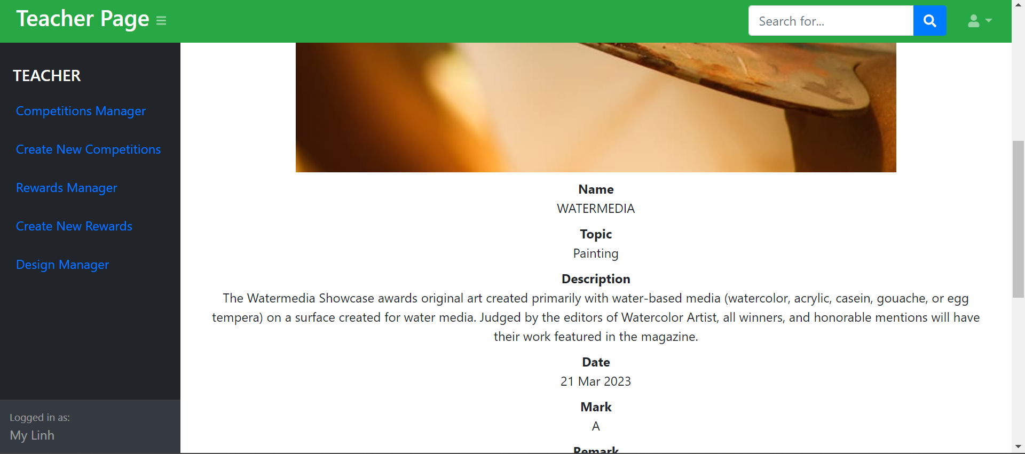

|  |  |
| --- | --- |
| **Controls on the Document** | **Description** |
| Back to list button | Go back user design page |

**24. Teacher manager Reward Page**

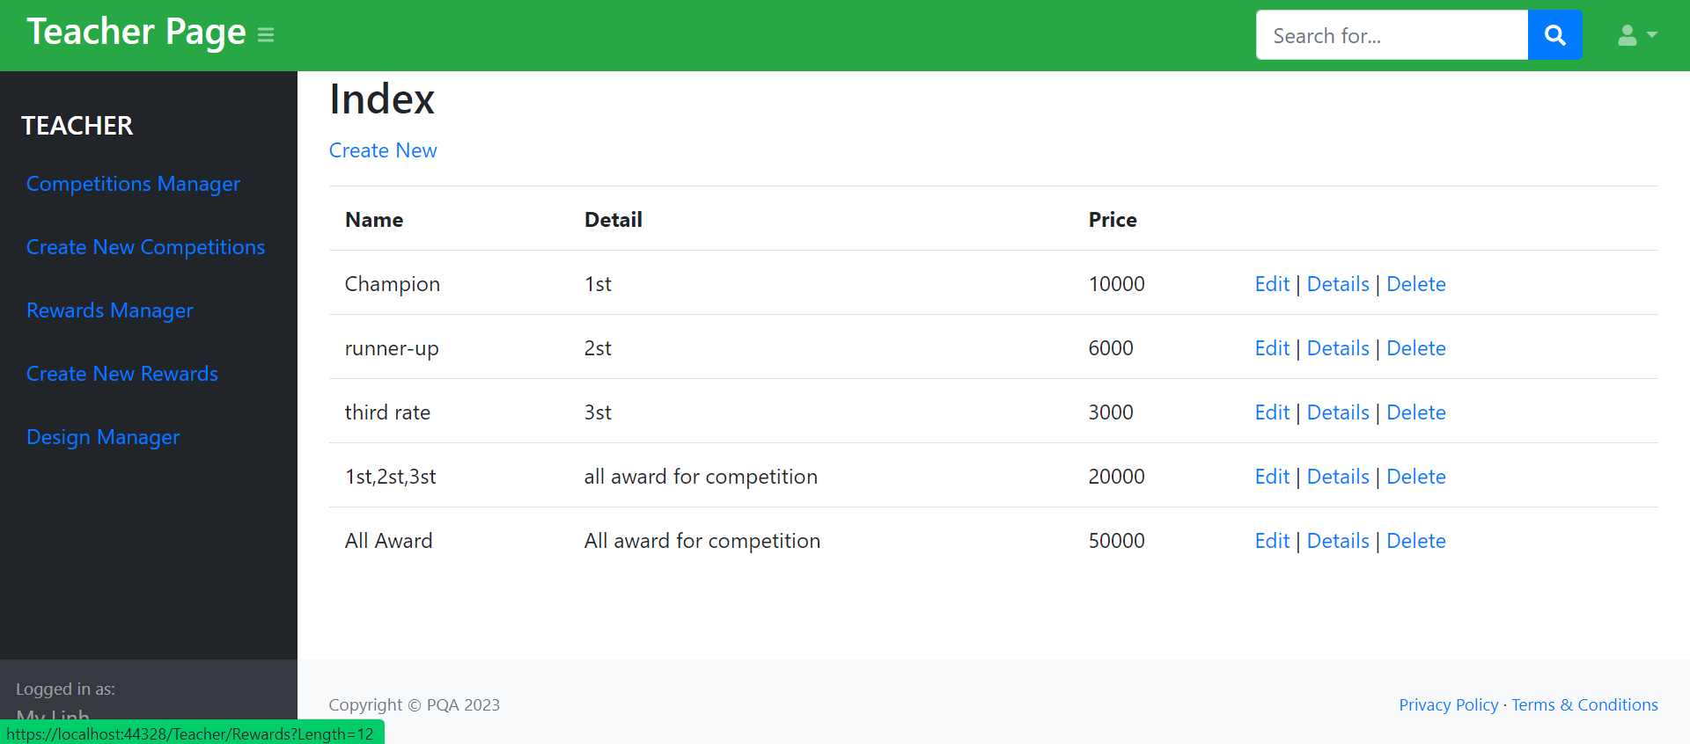

|  |  |
| --- | --- |
| **Controls on the Document** | **Description** |
| Edit link | Display edit reward page |
| Delete link | Display delete reward page |
| Detail link | Display detail reward page |
| Create link | Display Add reward page |

**DATABASE DESIGN DOCUMENT**

**I. ER/Class Diagram**

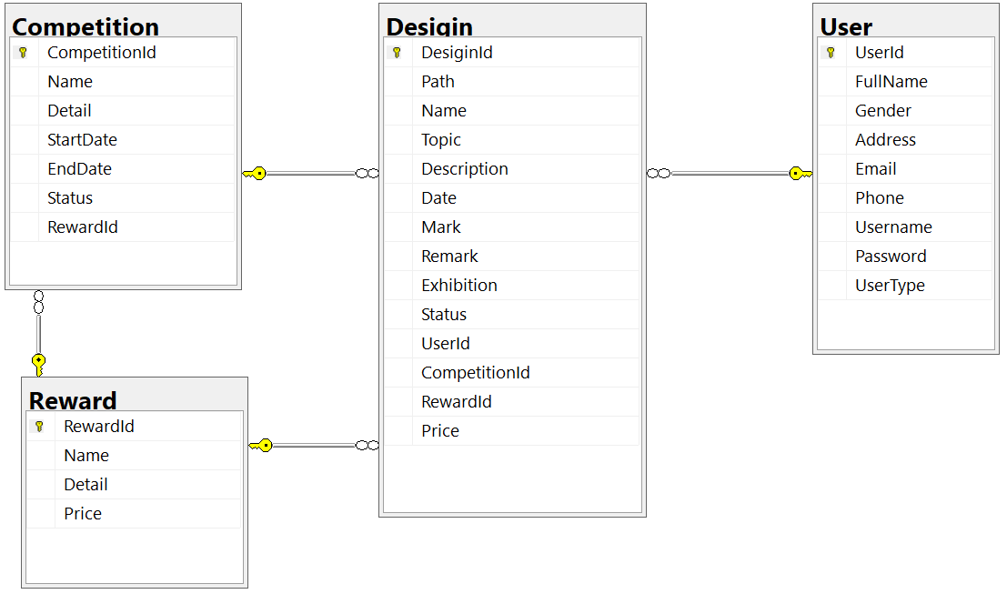

**II. Table Description**

|  |  |  |  |
| --- | --- | --- | --- |
| **User** | | | |
| **Field Name** | **Data Type** | **Constraint  (Primary Key, Foreign Key, Identity, Not Null,...)** | **Description** |
| UserId | int | Primary key, identity | Id of User |
| FullName | nvarchar(50) | Not null | Full name of User |
| Gender | nvarchar(50) | Not null | Gender of User |
| Address | nvarchar(200) | Not null | Address of User |
| Email | nvarchar(50) | Not null | Email of User |
| Phone | bigint | Not null | Phone of User |
| Username | nvarchar(50) | Not null | Username of User |
| Password | nvarchar(50) | Not null | Password of User |
| UserType | int | int | User Type of User |

|  |  |  |  |
| --- | --- | --- | --- |
| **Reward** | | | |
| **Field Name** | **Data Type** | **Constraint  (Primary Key, Foreign Key, Identity, Not Null,...)** | **Description** |
| RewardId | int | Primary key, identity | Id of Reward |
| Price | nvarchar(50) | Not null | Price of Reward |
| Price | nvarchar(200) | Not null | Price of Reward |
| Price | float | Not null | Price of Reward |

|  |  |  |  |
| --- | --- | --- | --- |
| **Competition** | | | |
| **Field Name** | **Data Type** | **Constraint  (Primary Key, Foreign Key, Identity, Not Null,...)** | **Description** |
| CompetitionId | int | Primary key, identity | Id of Competition |
| Name | nvarchar(200) | Not null | Name of Competition |
| Name | nvarchar(MAX) | Not null | Name of Competition |
| StartDate | date | Not null | StartDate of Competition |
| EndDate | date | Not null | EndDate of Competition |
| Status | int | Not null | Status of Competition |
| RewardId | int | Foreign key | Foreign key references to Reward table |

|  |  |  |  |
| --- | --- | --- | --- |
| **Desigin** | | | |
| **Field Name** | **Data Type** | **Constraint  (Primary Key, Foreign Key, Identity, Not Null,...)** | **Description** |
| DesiginId | int | Primary key, identity | Id of Desigin |
| Path | varchar(200) | Not null | Path of Desigin |
| Name | nvarchar(200) | Not null | Name of Desigin |
| Topic | nvarchar(50) | Not null | Topic for Desigin |
| Description | nvarchar(MAX) | Not null | Description for Desigin |
| Date | date | Not null | Date of Desigin |
| Mark | nvarchar(10) | Allow null | Mark for Desigin |
| Remark | nchar(10) | Allow null | Remark for Desigin |
| Exhibition | int | Allow null | Exhibition of Desigin (0 – Yes, 1 – No) |
| Status | int | Allow null | Status of Desigin (0 – Available, 1 – Sold Out) |
| UserId | int | Foreign key | Foreign key references to User table |
| CompetitionId | int | Foreign key | Foreign key references to Competition table |
| RewardId | int | Foreign key | Foreign key references to Reward table |
| Price | float | Allow null | Price of Desigin |

**PROCESS DESIGN DOCUMENT**

(Activity diagram, sequence diagram)

**1. Activity Diagram**

**1. Login**

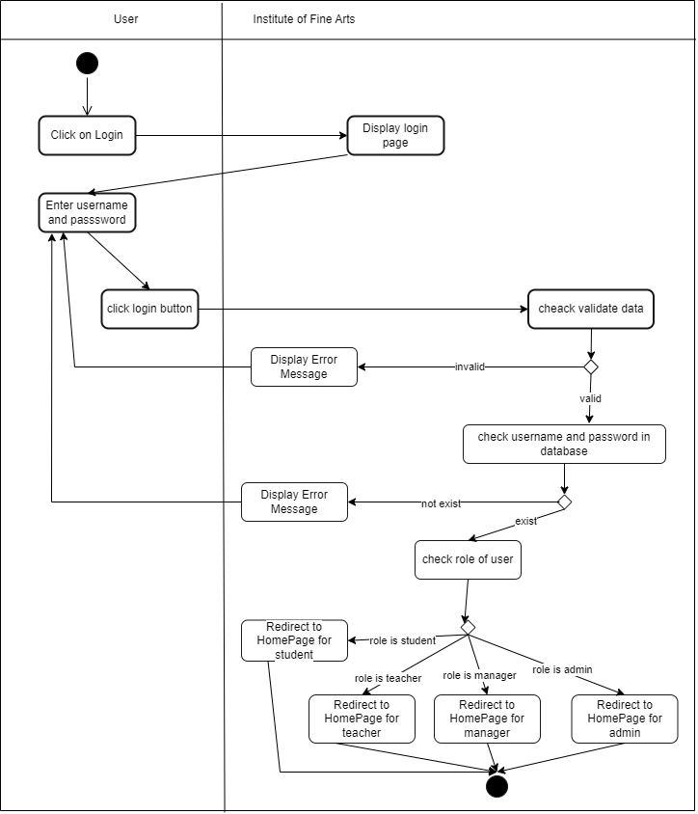

**2. Manage Design**

**2.1 Add new Design**

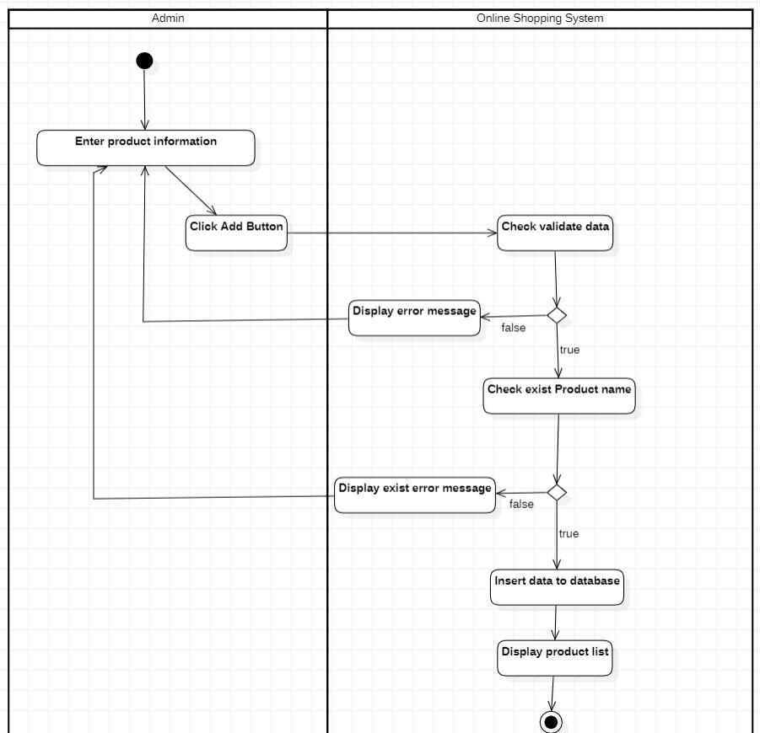

**2.2 Update Design**

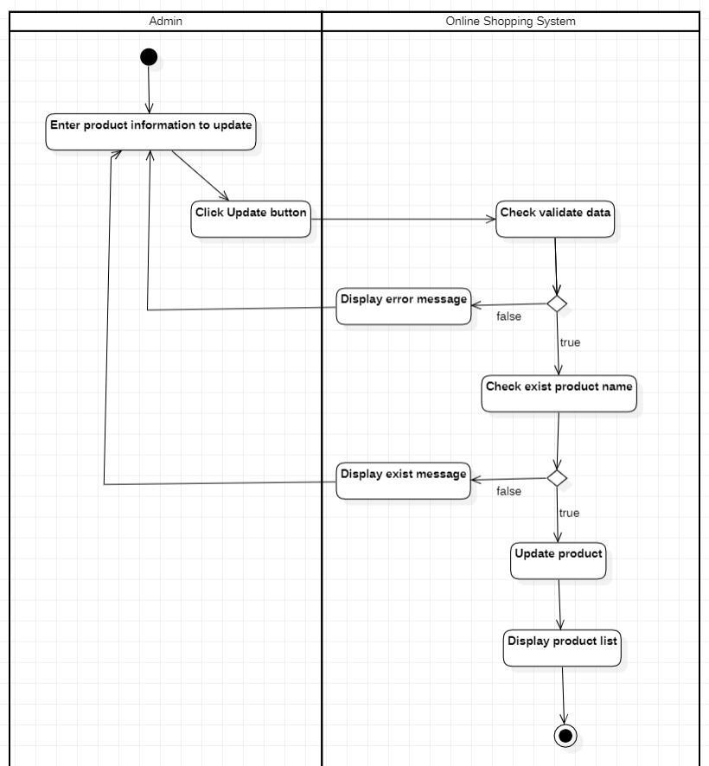

**2.2 Delete Design**

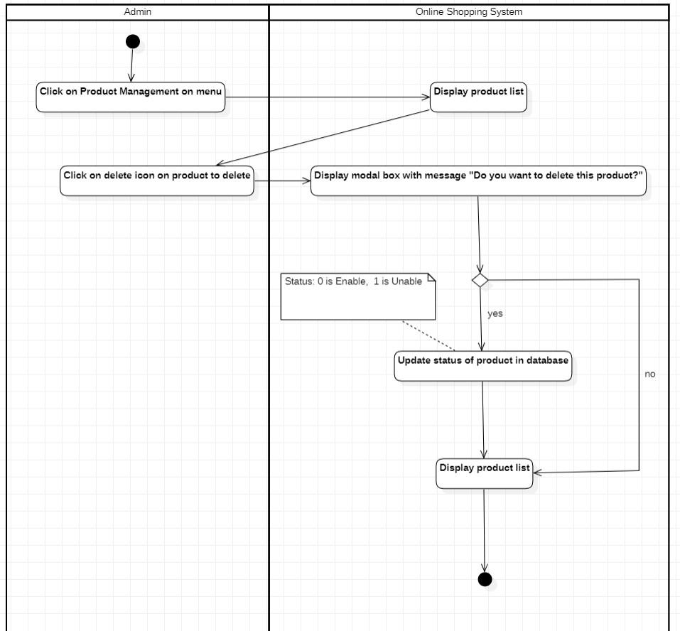

**3. Sequences Diagram**

**3.1 Manage Design**

**3.1.1 Add new Design**

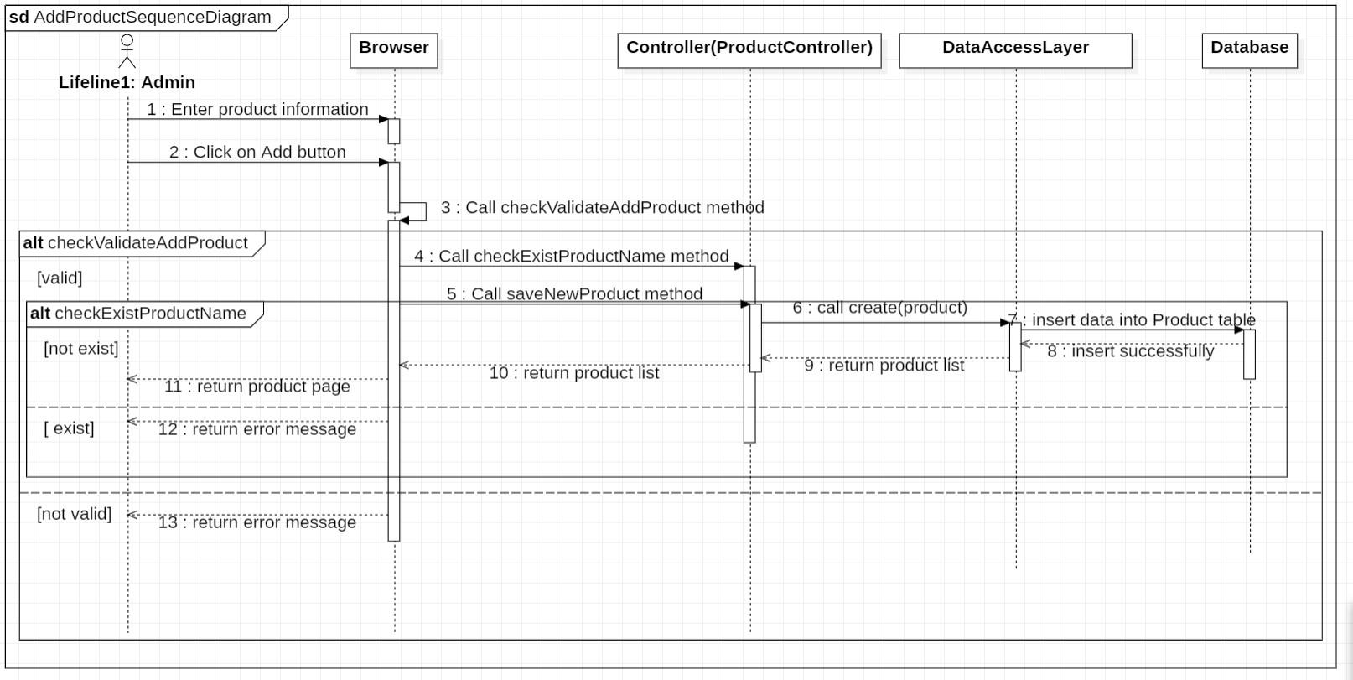

**2.1.2 Update Design**

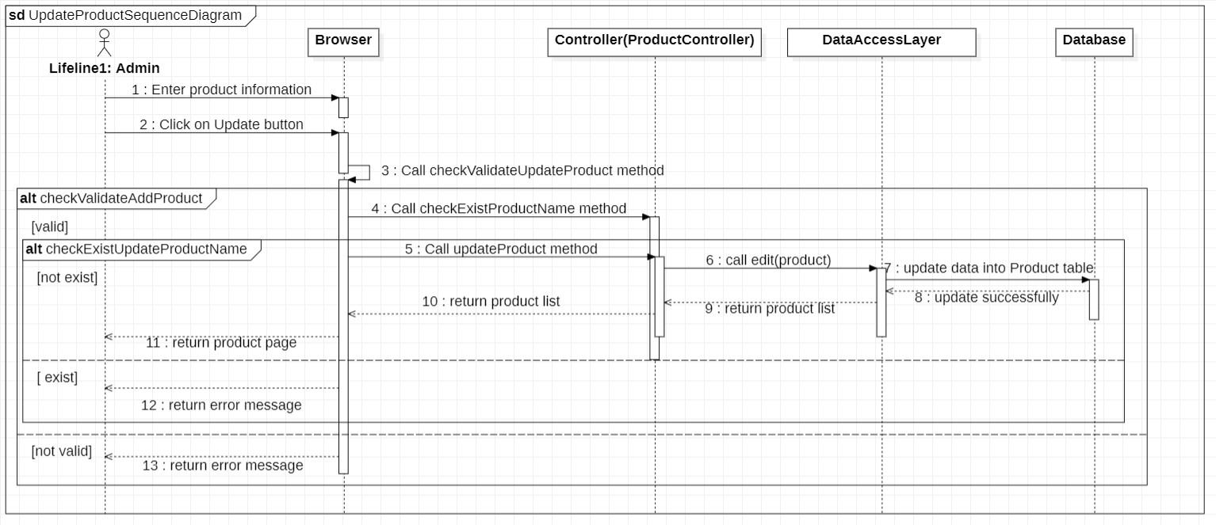

**2.1.3 Delete Design**

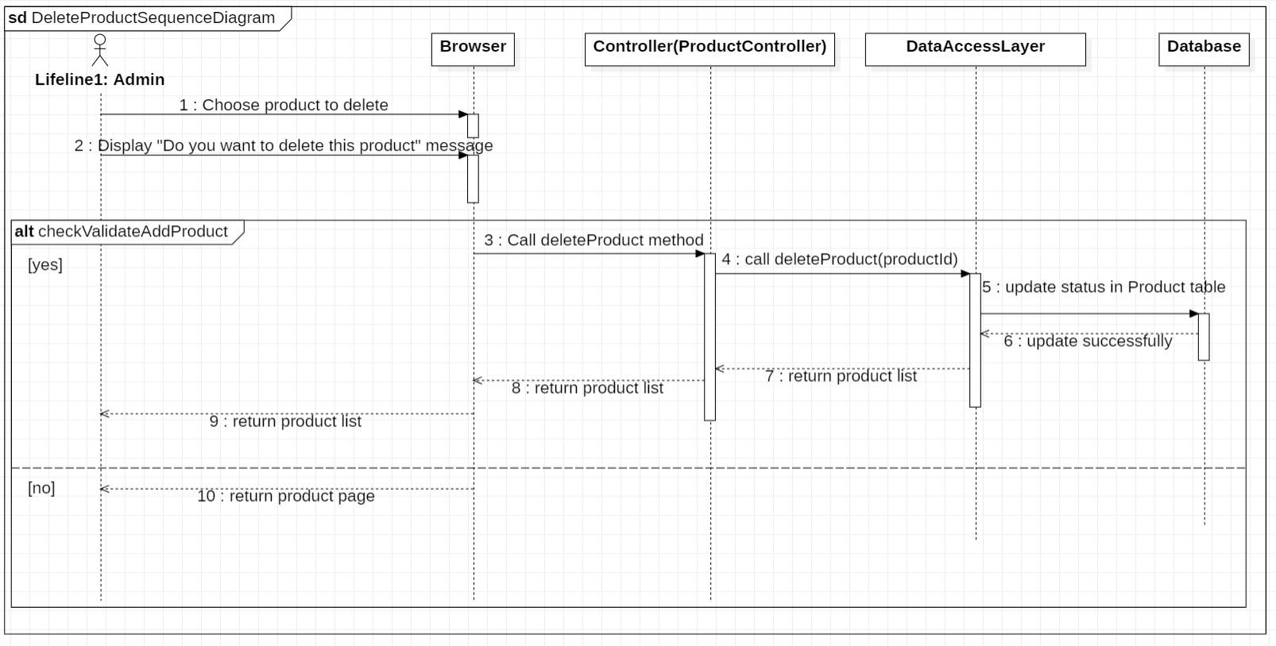

**TASK SHEET**

1. Project Title: Online Shopping

|  |  |  |  |  |  |
| --- | --- | --- | --- | --- | --- |
| **No.** | **Task** | **Actual Start Date** | **Actual Days** | **Teammate Name** | **Status** |
|  | Form 01_Problem Definition Document | 1/3/2023 | 2 | Pham Quoc Anh | Done |
|  | Form 02A_Customer Requirements Specification (CRS) | 3/3/2023 | 3 | Pham Quoc Anh | Done |
|  | Form 02B_Customer Acceptance Criteria | 4/3/2023 | 2 | Pham Quoc Anh | Done |
|  | Form 03_Project Plan | 5/3/2023 | 3 | Pham Quoc Anh | Done |
|  | Form 04_Architecture & GUI Standard of Application | 7/3/2023 | 2 | Pham Quoc Anh | Done |
|  | Form 05_Interface Design Document | 10/3/2023 | 3 | Pham Quoc Anh | Done |
|  | Form 06_Table Design Document | 12/3/2023 | 2 | Pham Quoc Anh | Done |
|  | Form 07_Process Design Document | 15/3/2023 | 5 | Pham Quoc Anh | Done |
|  | Form 09_Task Sheet | 18/3/2023 | 1 | Pham Quoc Anh | Done |
|  | Form 10_Testing Document | 19/3/2023 | 2 | Pham Quoc Anh | Done |
|  | Form 11_Project Review | 20/3/2023 | 1 | Pham Quoc Anh | Done |
|  | Form 12_Final Check List | 20/3/2023 | 1 | Pham Quoc Anh | Done |
|  | Manage User( consist of register, login, logout, delete user) | 10/3/2023 | 4 | Pham Quoc Anh | Done |
|  | Manage Competition (Add/Update/Delete Competition) | 8/3/2023 | 5 | Pham Quoc Anh | Done |
|  | Manage Design(consist of add, update, delete Design, display Design, display new Design, view Design detail) | 20/3/2023 | 3 | Pham Quoc Anh | Done |
|  | Manage Reward(consist of add, update, delete Reward) | 16/3/2023 | 2 | Pham Quoc Anh | Done |
|  | Statistic(Revenue, draw revenue chart) | 7/3/2023 | 3 | Pham Quoc Anh | Done |

**TESTING DOCUMENT**

|  |  |  |  |  |
| --- | --- | --- | --- | --- |
| **ID** | **Test Case Name** | **Task** | **Result** | |
| **Expected** | **Actual Result**  Pass/Fail-Comments |
| 1. | Add Competition | Enter Competition:  Competition Name: Honey | Record is added to the database | Pass |
| 2. | Edit Competition | Select Competition:  Competition Name: Honey demo | Record is edit to the database | Pass |
| 3. | Delete Competition | Select Competition:  Competition Name: Honey demo | Record is delete to the database | Pass |
| 4. | Add Design | Enter Design:  Design Name: Demo  Design Path: demo.jpn  Design Des: demo demo  Design Topic: Demo | Record is added to the database | Pass |
| 5. | Edit Design | Enter Design:  Design Name: Demo1  Design Path: demo1.jpn  Design Des: demo1 demo  Design Topic: Demo1 | Record is edit to the database | Pass |
| 6. | Delete Design | Select Design:  Design Name: Demo1 | Record is delete to the database | Pass |
| 8. | Log in | Enter Username : demo  Enter Pass : demo | Record is search to the database if account exist | Pass |
| 9. | Logout | Click Logout button | Destroy session | Pass |
| 12. | Delete User | Select User: demo | Record is delete to the database | Pass |

**PROJECT REVIEW**

|  |  |  |  |  |  |
| --- | --- | --- | --- | --- | --- |
| **Date** | **Project Plan Activity/Milestone** | **Work Specification** | **Status of the Activity** | **Remarks** | **Responsibility** |
| 21/2/2023 | 1/3/2023 | Take Customer’s information | Finished | Good | Pham Quoc Anh |
| 1/3/2023 | 13/3/2023 | Design | Finished | Good | Pham Quoc Anh |
| 13/3/2023 | 20/3/2023 | Coding | Finished | Good | Pham Quoc Anh |
| 15/3/2023 | 20/3/2023 | Testing | Finished | Good | Pham Quoc Anh |

|  |  |  |
| --- | --- | --- |
| **S.No.** | **Aspect tested** | **Suggestion/Remarks** |
|  | Have all the modules been property integrated and are they completely functional? | Yes |
|  | Are all the validations happening as specified in Process Design? | Yes |
|  | Have all Design and Coding standards been followed and implemented? | Yes |
|  | Have all the modules been property integrated and are they completely functional? | Yes |
|  | Are all the validations happening as specified in Process Design? | Yes |
|  | Have all Design and Coding standards been followed and implemented? | Yes |
|  | Have all the modules been property integrated and are they completely functional? | Yes |
|  | Are all the validations happening as specified in Process Design? | Yes |

**I/ Installations**

1. Download to file **CP2296F02_Group4_InstituteOfFineArts**.zip to your computer.

2. Unzip file **CP2296F02_Group4_InstituteOfFineArts** by Winrar or use any unzip software

Click right mouse on file:

Then, click choose Oppen With -> Windows Explorer

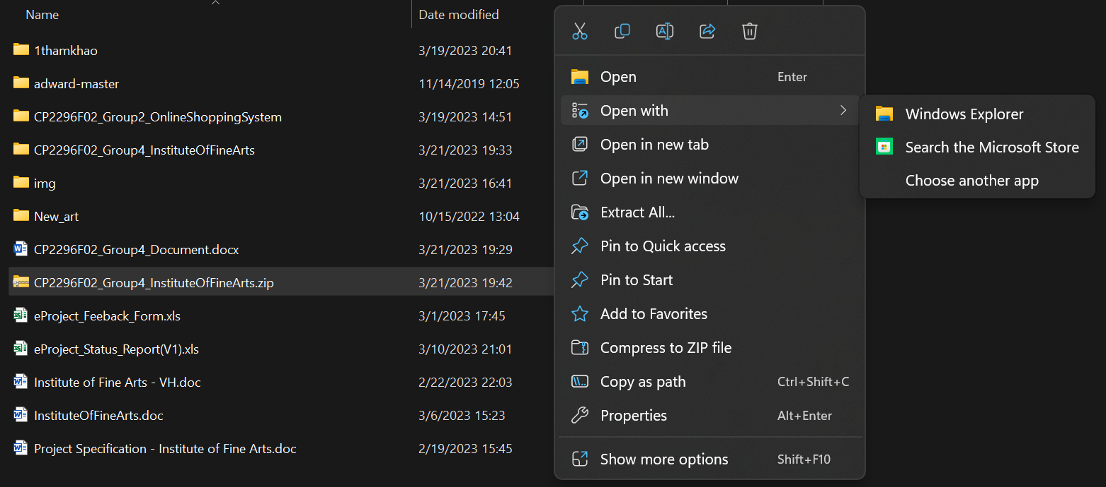

Then open file data.sql in databse folder with Microsoft SQL Server Management Studio 18

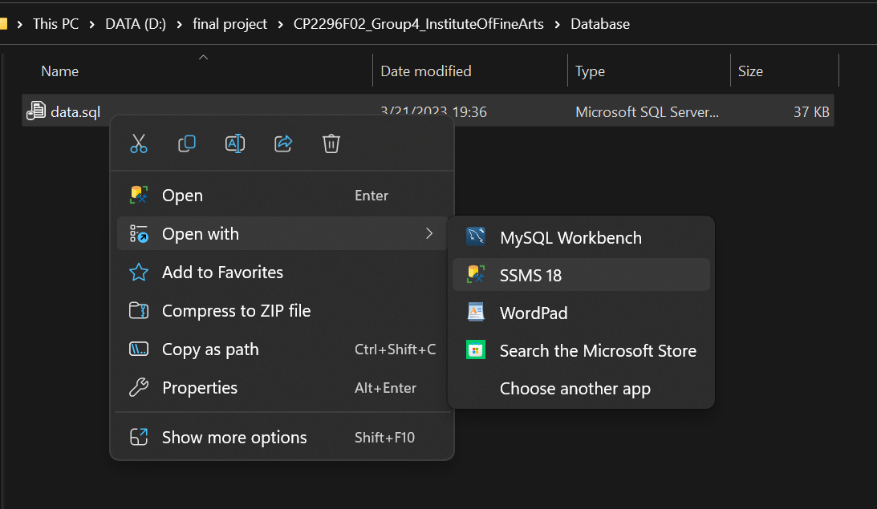

Then Create New database

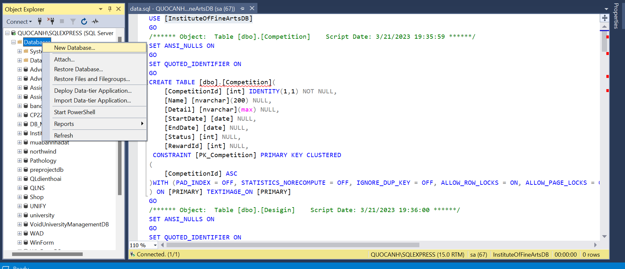

With name “ InstituteOfFineArtsDB”

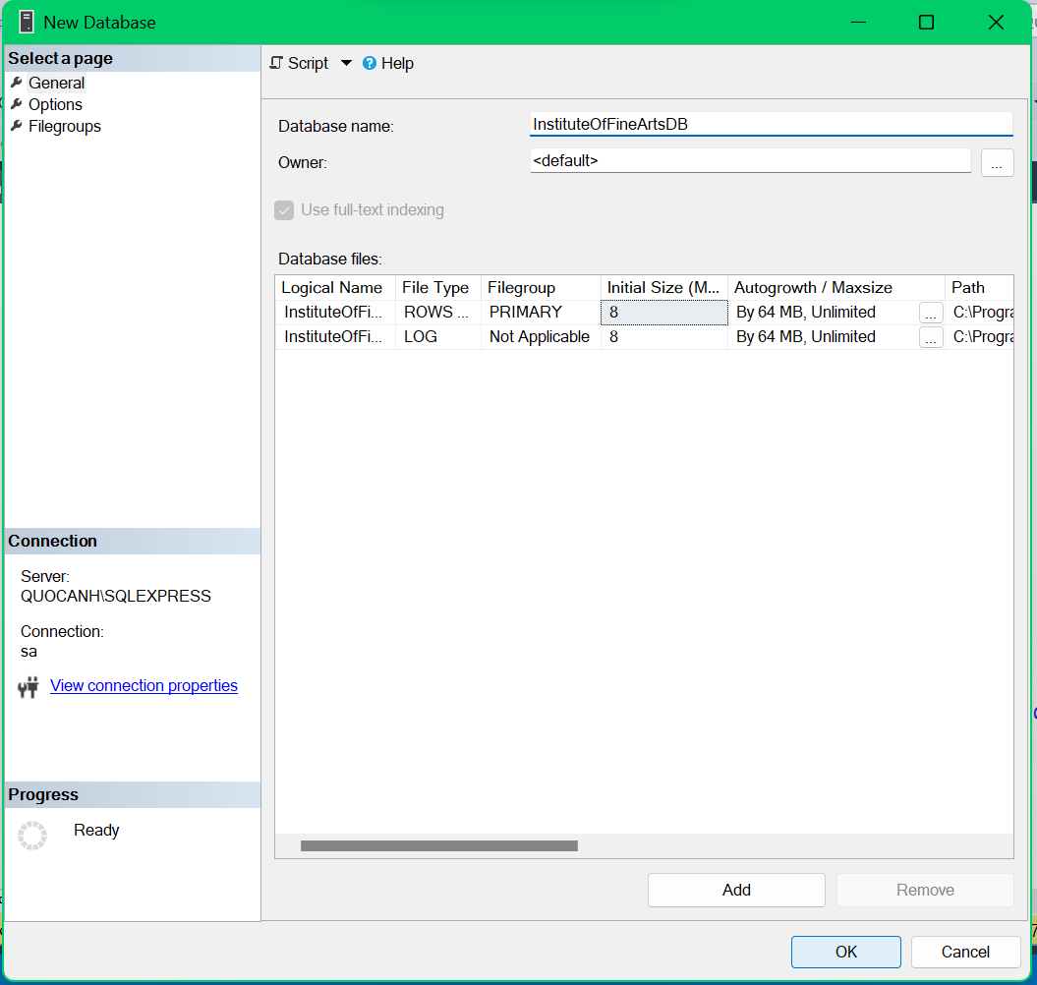

Then you click Execute button or press F5

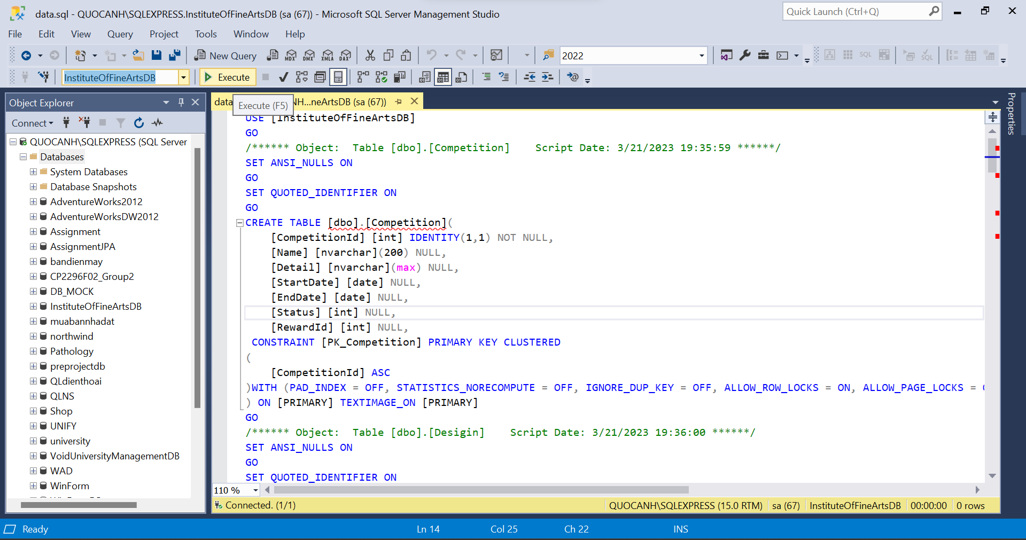

Open Visual Studio 2019 then click File -> Open project or solution -> **InstituteOfFineArts.sln**

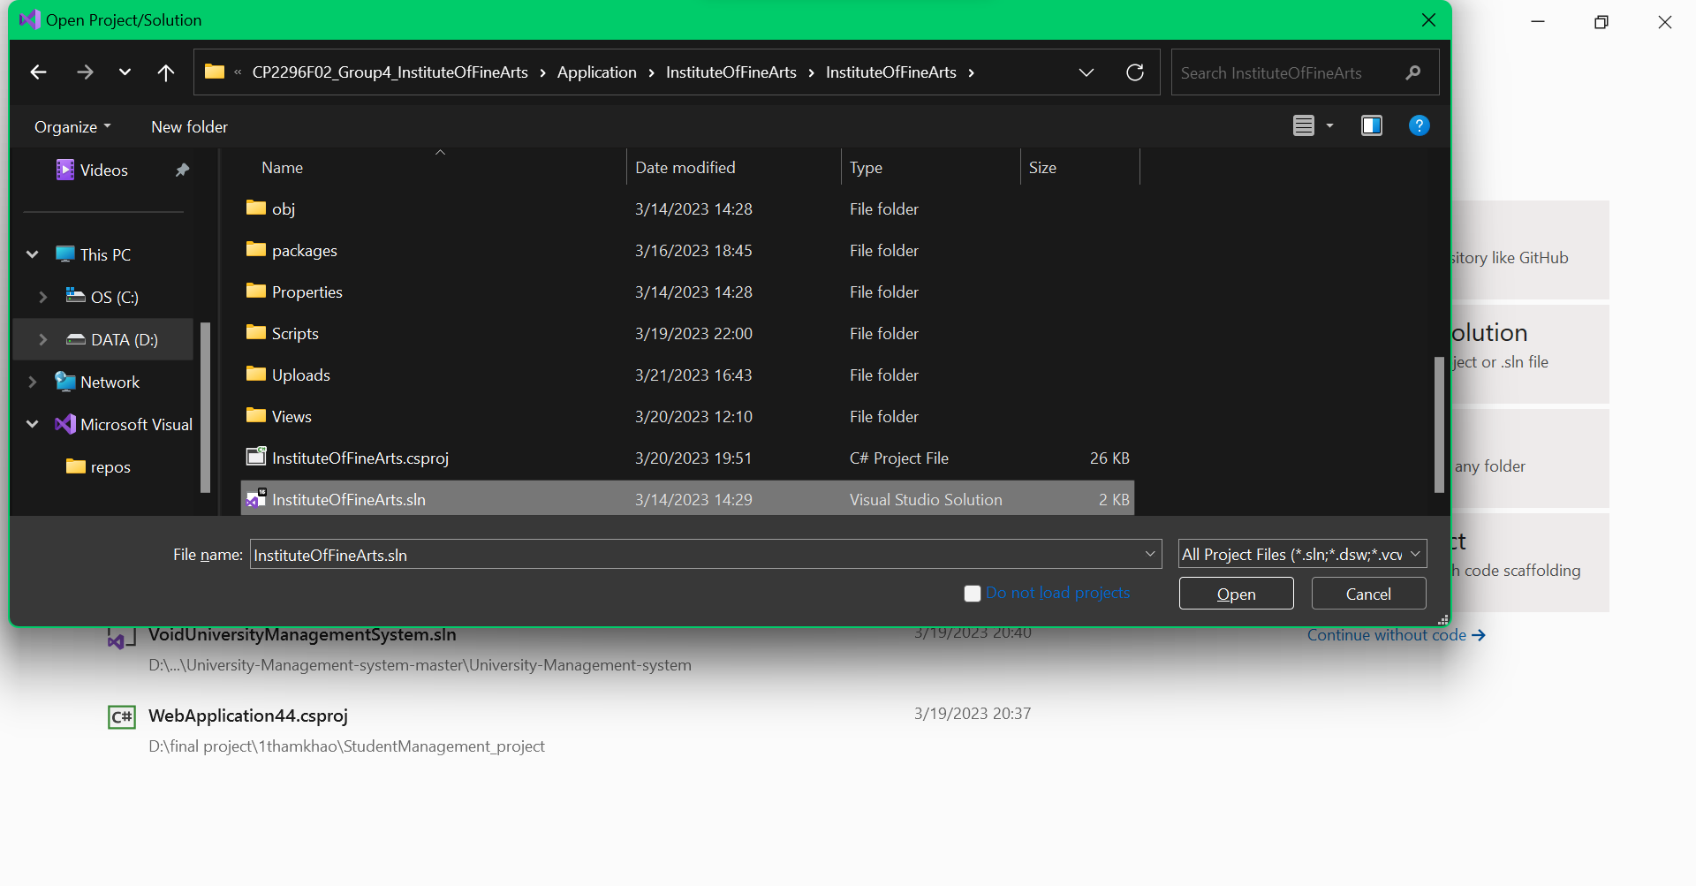

Then click on IIS Express button.

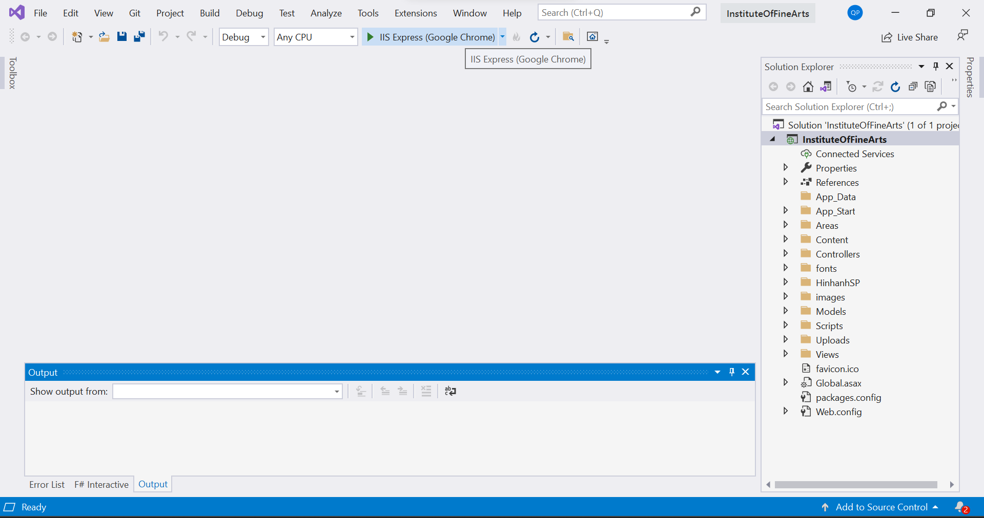

* **Project connect database with**

Username : sa

Password : sa

If your connect database with different username or password

Please go to Web.config and change username or password of your connect to Microsoft SQL Server Management Studio 18

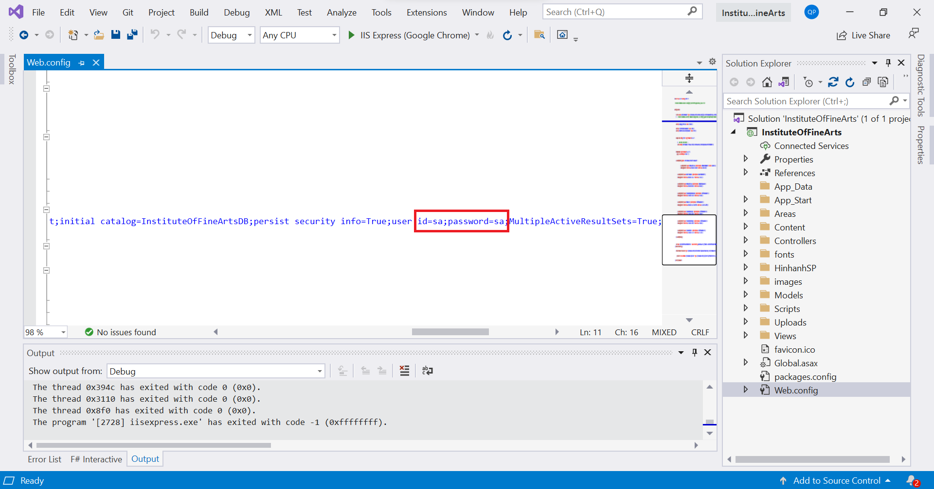

Then you go to login page



Website have 4 type of User :

* To go into Admin Page, you need login with:

Username : Amin

Password : 12345

* To go into Manager Page, you need login with:

Username : Manager

Password : 12345

* To go into Teacher Page, you need login with:

Username : Teacher

Password : 12345

* To go into Student Page, you need login with:

Username : Student

Password : 12345